HOW FILTER BANDWIDTH AFFECTS MEASURES OF FREQUENCY BANDWIDTH for five different chipping sparrow songs

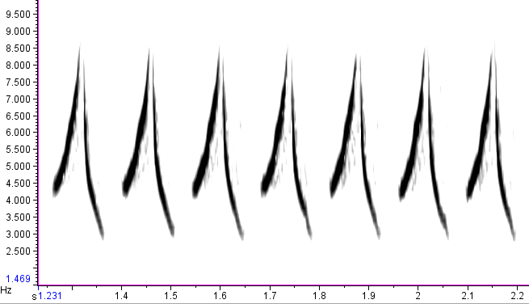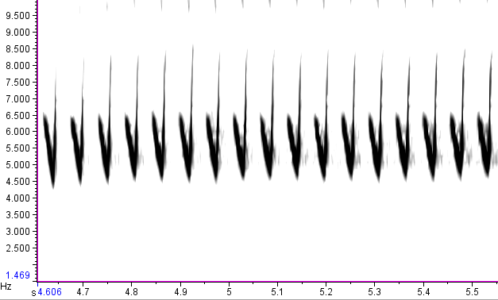
Song type 2
Song type 1

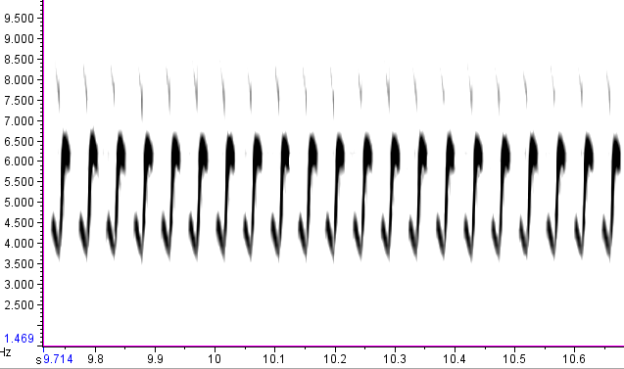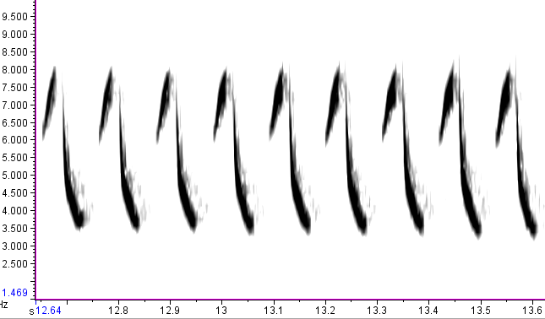
Song type 4
Song type 3

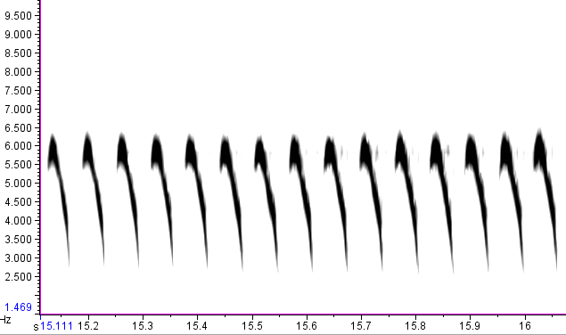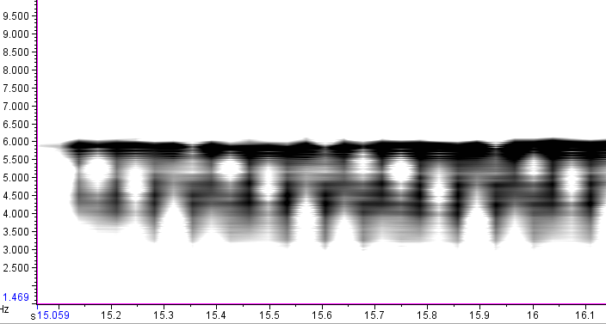
Song type 5—270 Hz filter
Song type 5—20 Hz filter
Figure 1. One-second excerpts from sonagrams of the five chipping sparrow song types used to explore how measures of frequency bandwidth and therefore “vocal deviation” are affected by the filter bandwidth used in software programs. Wide-band sonagrams (e.g., 270 Hz filter, as used on 5 of the 6 sonagrams) provide aesthetically pleasing sonagrams and accurate temporal measurements; narrow-band sonagrams (e.g., 20 Hz filter) are essential for measuring frequency accurately. For song type 5, the frequency bandwidth (at -24 db from max power) is shown for a 20 Hz filter bandwidth (red; 3578 to 6046 Hz) and a 270 Hz bandwidth (blue; 3270 to 6244 Hz; see also Figure 2).

Frequency bandwidth
at –24dB (Hz)
Filter bandwidth (Hz)
Song type #5

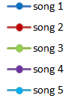
Percent "error"
on frequency
bandwidth
Filter bandwidth (Hz)

Figure 2. The filter bandwidth (i.e., frequency resolution) used in software programs strongly affects measures of frequency bandwidth. Best filter bandwidths for chipping sparrows are from 10-30 Hz (I used 20 Hz for analyses), after which resolution becomes increasingly less accurate. Primary curve is for song type #5 (Figure 1), with only the 300 Hz bandwidth plotted for songs 1-4; "percent error" is the difference in frequency bandwidth from that measured with a 20 Hz filter bandwidth. Frequency resolutions used by different authors range widely; in black diamonds are plotted some of the high extremes, at 350, 300, 195, 172, 98, and 94 Hz (Cramer & Price, 2007; Podos, 1997; Beebee, 2004; DuBois et al., 2009; Ballentine et al., 2004; Vehrencamp et al., 2013, respectively). How the filter bandwidth affects songs of other species awaits further description.
References
Ballentine, B., Hyman, J., & Nowicki, S. (2004). Vocal performance influences female response to male bird song: An experimental test. Behavioral Ecology, 15, 163e168.
Beebee, M. D. (2004). Variation in vocal performance in the songs of a wood-warbler: Evidence for the function of distinct singing modes. Ethology, 110, 531-542.
Cramer, E. R. A., & Price, J. J. 2007. Red-winged blackbirds Ageliaus phoeniceus respond differently to song types with different performance levels. Journal of Avian Biology, 38, 122-127.
DuBois, A. L., Nowicki, S., & Searcy, W. A. (2009). Swamp sparrows modulate vocal performance in an aggressive context. Biology Letters, 5(2), 163e165. http://dx.doi.org/10.1098/rsbl.2008.0626.
Podos, J. (1997). A performance constraint on the evolution of trilled vocalizations in a songbird family (Passeriformes: Emberizidae). Evolution, 51, 537e551.
Vehrencamp, S. L., Yantachka, J., Hall, M. L., & de Kort, S. R. (2013). Trill performance components vary with age, season, and motivation in the banded wren. Behavioral Ecology and Sociobiology, 67, 409e419.

